Software Design and Analysis Assignment 2
Group Members:
Ali Irtaza Abbas Siddiqui (24P-0607)
Hammad Kashif (24P-0631)
Muqeet Mehmood (24P-0606)
1. Class Diagram
The class diagram shows the project’s main components through: StudentFaculty FYP_Group Deliverable Supervision_Request Job_Posting System_Admin and Clearance_Record entities. All entity components are displayed through their specific attributes and operational functions and their connections to other entities. Students create groups to present their work while they seek job opportunities and faculty members evaluate their academic performance through submitted materials. The diagram shows how administrative staff uses their authority to handle both record maintenance and job advertisement management. The system architecture and object-oriented design of the system become clear through this representation.
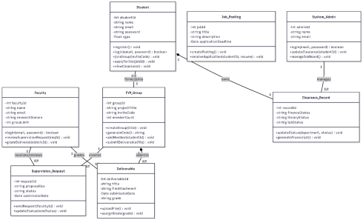
2. Sequence Diagram mapped on Class Diagram
The sequence diagram shows how students interact with system interfaces and supervision request modules when they submit their proposals. The student starts the process by choosing a faculty member and adding a proposal file before submitting their request. The system processes this action by sending the request to the supervision module, which updates the request status to “Pending.” A notification is sent to the faculty member as the last step of the process. The diagram shows how system components interact with each other through their operational sequences.
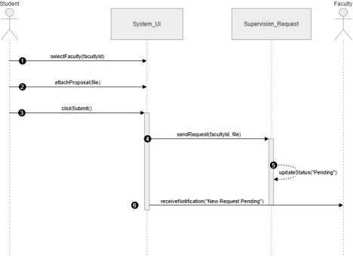
3. Activity Diagram
The activity diagram demonstrates how users submit deliverables through the full workflow. The process starts when students log in to their accounts and access the deliverables dashboard to choose a milestone and upload their documents. The system validates the uploaded file; if it fails validation an error message appears and the user must re-upload their document. The system stores the valid file in the database and updates the submission status to "Submitted" while
notifying the faculty supervisor. The diagram shows the complete process of submission handling together with all decision-making points.
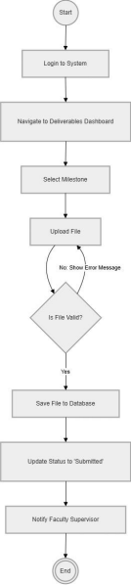
4. State Machine
The diagram shows how the project request system works by displaying all the request states which depend on user and system activities. A request starts when someone creates it and the system saves it in the Draft state. The request moves to Pending Review after the user submits it through sendRequest(), which puts it into the Pending Review state. The request enters two possible outcomes at this point through facultyApprove(), which leads to an Accepted state, and facultyDeny(), which results in a Rejected state. The project reaches completion through projectCompleted() after the request receives approval, while the request reaches finalization after acknowledgeRejection() in case of a rejection. The process ends in Archived/Closed state for both cases because this state shows that request processing has finished.
